PROJECT REPORT

Project Title : Educational Organisation Using ServiceNow

INTRODUCTION

Project Overview
The project titled “Educational Organisation Using ServiceNow” aims to digitize and automate the core administrative processes of an educational institution using the ServiceNow platform. The system provides a centralized environment to manage student-related data, streamline admission processes, and handle academic workflows efficiently.
By utilizing ServiceNow’s low-code/no-code capabilities, the application enables administrators to create custom tables, design user-friendly forms, automate processes using workflows, and implement client-side scripting for validations and calculations. This approach improves operational efficiency, reduces manual effort, and ensures better data accuracy.

Purpose
The purpose of this project is to reduce manual administrative work in educational organizations by implementing an automated service management system using ServiceNow. The solution focuses on improving data handling, minimizing errors, and providing real-time visibility into student and academic records. It also helps administrators manage workflows effectively through automated process flows and reports.

IDEATION PHASE

2.1 Problem Statement
Educational institutions often manage student admissions, academic progress, and related administrative data manually or using disconnected systems. This manual approach leads to data redundancy, delays in processing, and difficulty in tracking student information efficiently. There is a need for a centralized digital platform that can manage admissions, maintain student progress records, and support administrative workflows in a structured and automated manner.

2.2 Empathy Map Canvas
Users:
- Educational Institution Administrators
- Admission Coordinators
- Academic Staff
Needs:
- Centralized access to student and admission data
- Automated record management
- Easy tracking of student academic progress
Pains:
- Manual data entry
- Time-consuming admission processing
- Difficulty in monitoring student performance
Gains:
- Faster admissions processing
- Accurate and real-time student records
- Improved administrative efficiency

2.3 Brainstorming
Based on the identified problem, the following ideas were considered during brainstorming:
- Use the ServiceNow platform as a centralized system
- Create custom tables for Salesforce, Admission, and Student Progress
- Design structured forms for easy data entry
- Implement process flows to manage the admission lifecycle
- Use client scripts for automation, validation, and calculations
- Generate real-time records for tracking student progress

REQUIREMENT ANALYSIS

3.1 Customer Journey Map
The student data follows a three-stage lifecycle to ensure accuracy:
- Registration: Master data is entered in the Salesforce table and a unique SAL ID is generated.
- Enrollment: The Admission table pulls student data via the Auto-populate script.
- Evaluation: Academic marks are recorded in the Student Progress table where results are calculated automatically.

3.2 Solution Requirements
- Unique Identification: Every student must have a unique ID using Number Maintenance.
- Process Automation: Data must flow from Salesforce to Admission via Reference fields and Client Scripts.
- Calculated Results: Total, Percentage, and Result (Pass/Fail) must be calculated instantly without manual input.
- Data Security: Academic calculation fields must be Disabled (Read-Only) to prevent accidental changes.

3.3 Data Flow Diagram
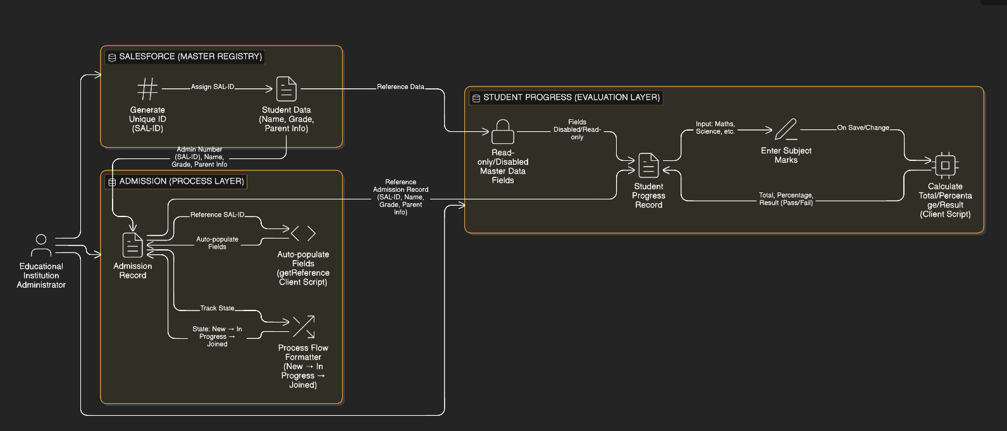

3.4 Technology Stack
- Platform: ServiceNow (Cloud-based PaaS).
- Database: Custom Tables (u_salesforce, u_admission, u_student_progress).
- Scripting: JavaScript (Client-side g_form API).
- Formatting: Form Designer and Process Flow Formatter.

PROJECT DESIGN

4.1 Problem-Solution Fit
• Manual Gap: Disconnected systems cause data errors and slow admission processing.
• The Fit: ServiceNow centralizes records and uses scripts to eliminate repetitive data entry.

4.2 Proposed Solution
• Master Registry: The Salesforce table acts as the primary "Source of Truth".
• Workflow: A Process Flow Formatter on the Admission form tracks status visually.
• Automation: Client Scripts handle complex calculations and auto-population.

4.3 Solution Architecture
• Relational Model: Admission records reference the Salesforce table for unique student identities.
• Scripting Layer: GlideForm scripts manage UI changes and automated calculations.

PROJECT PLANNING & SCHEDULING

5.1 Project Planning
• Weeks 1-2: Instance setup and Database Architecture (Salesforce, Admission, Progress tables).
• Weeks 3-4: UI Configuration (Form Design) and implementation of Client Scripts/Process Flows.
• Week 5: Functional testing and project documentation.

FUNCTIONAL & PERFORMANCE TESTING

6.1 Performance Testing
• Efficiency: Automated fields and script triggers respond in < 1 second.
• Accuracy: Calculations for Total, Percentage, and Result update instantly and correctly.
• Security: The Disable Fields script successfully protects master data as Read-Only.

RESULTS

7.1 Output Screenshots

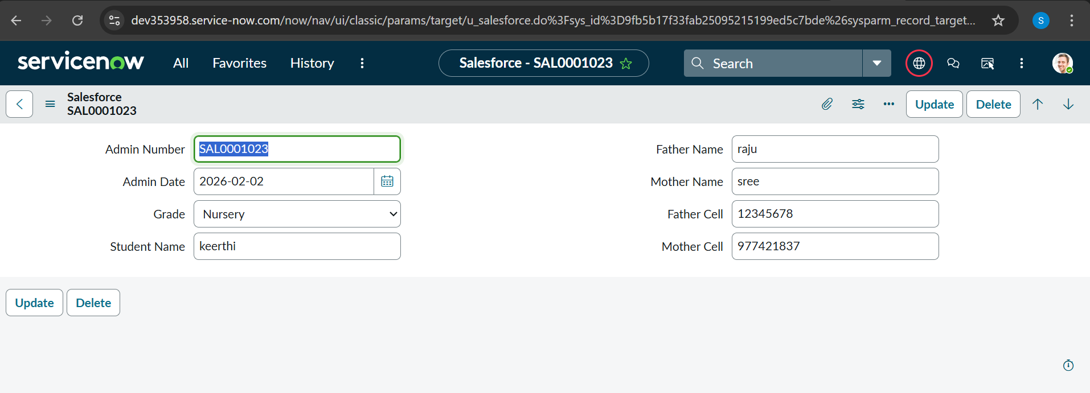
Figure 1: Salesforce master record with automated SAL ID generation.

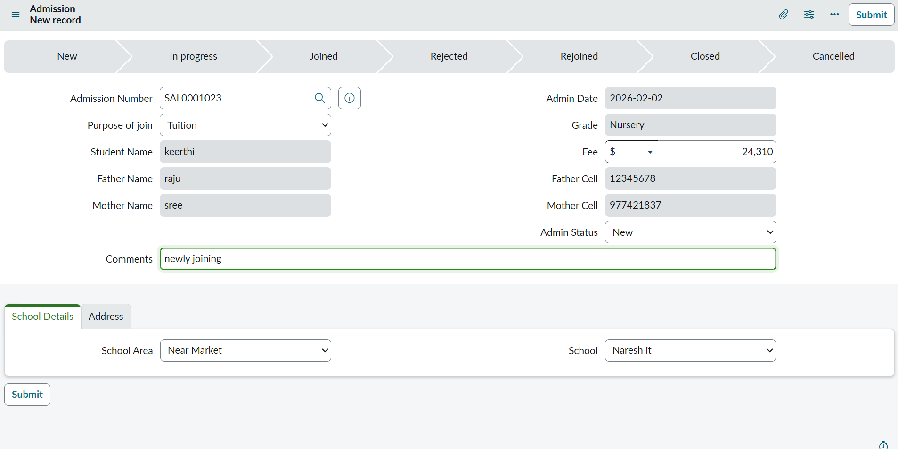
Figure 2.1: Admission form showing automated data retrieval via Client Scripting.

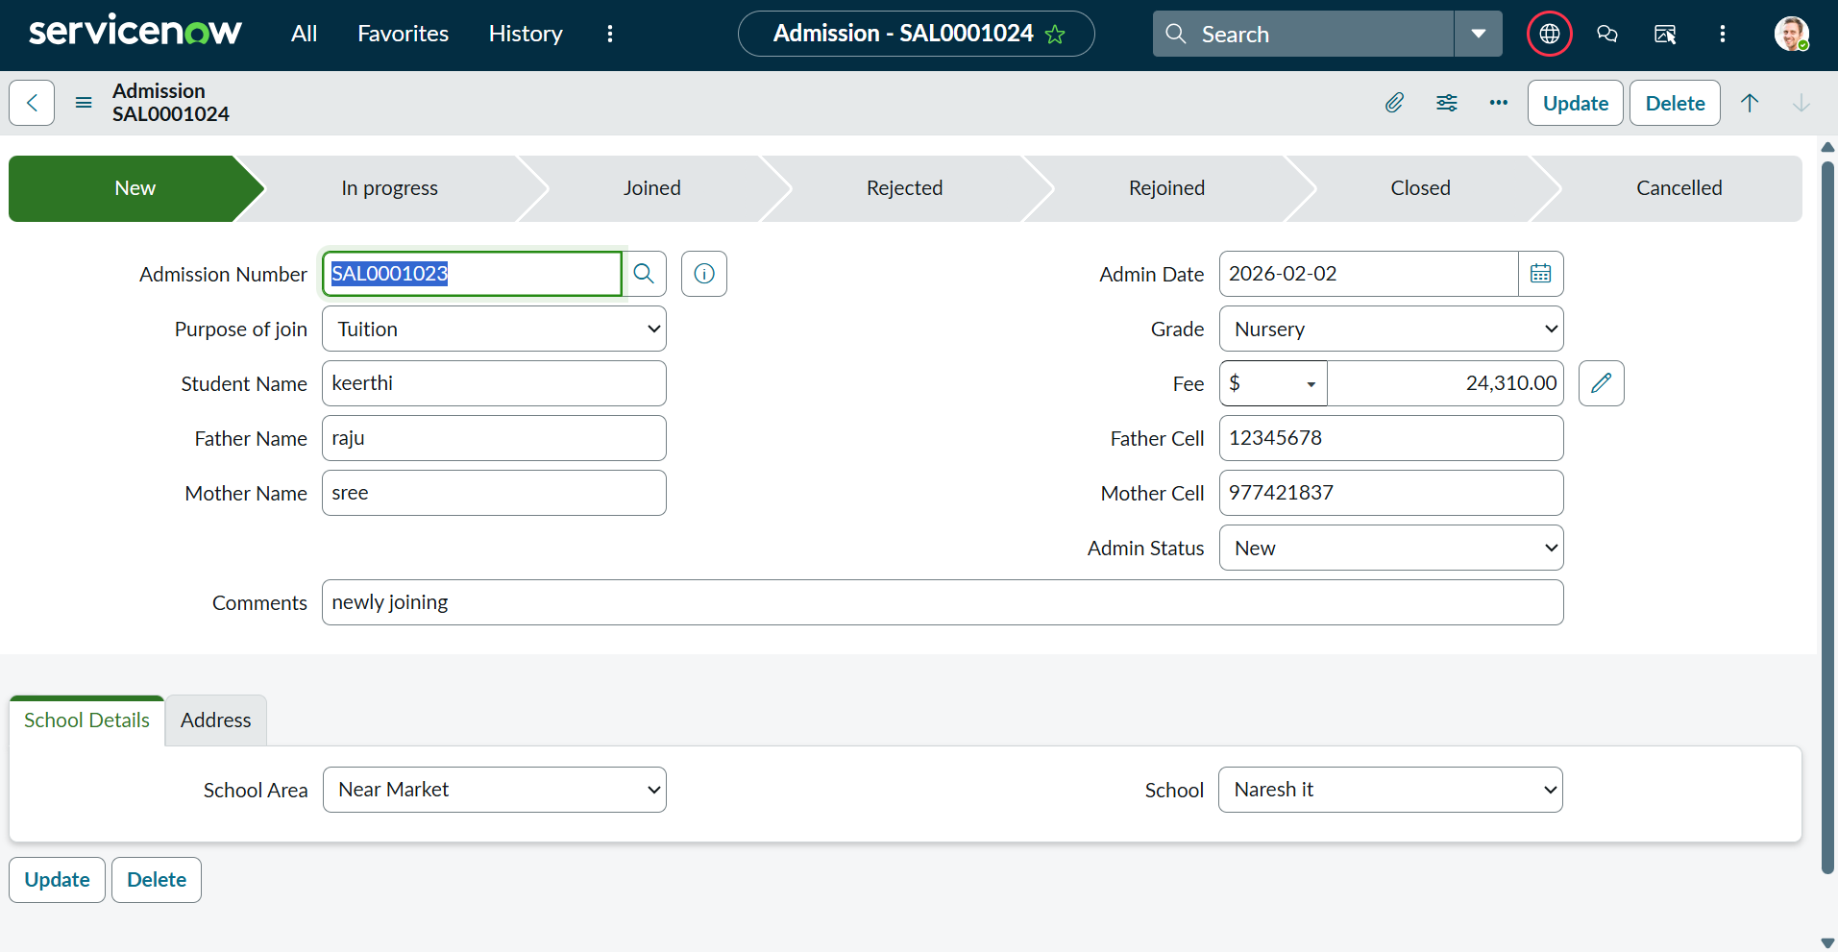
Figure 2.2: Admission record highlighting the Process Flow Formatter for lifecycle tracking.

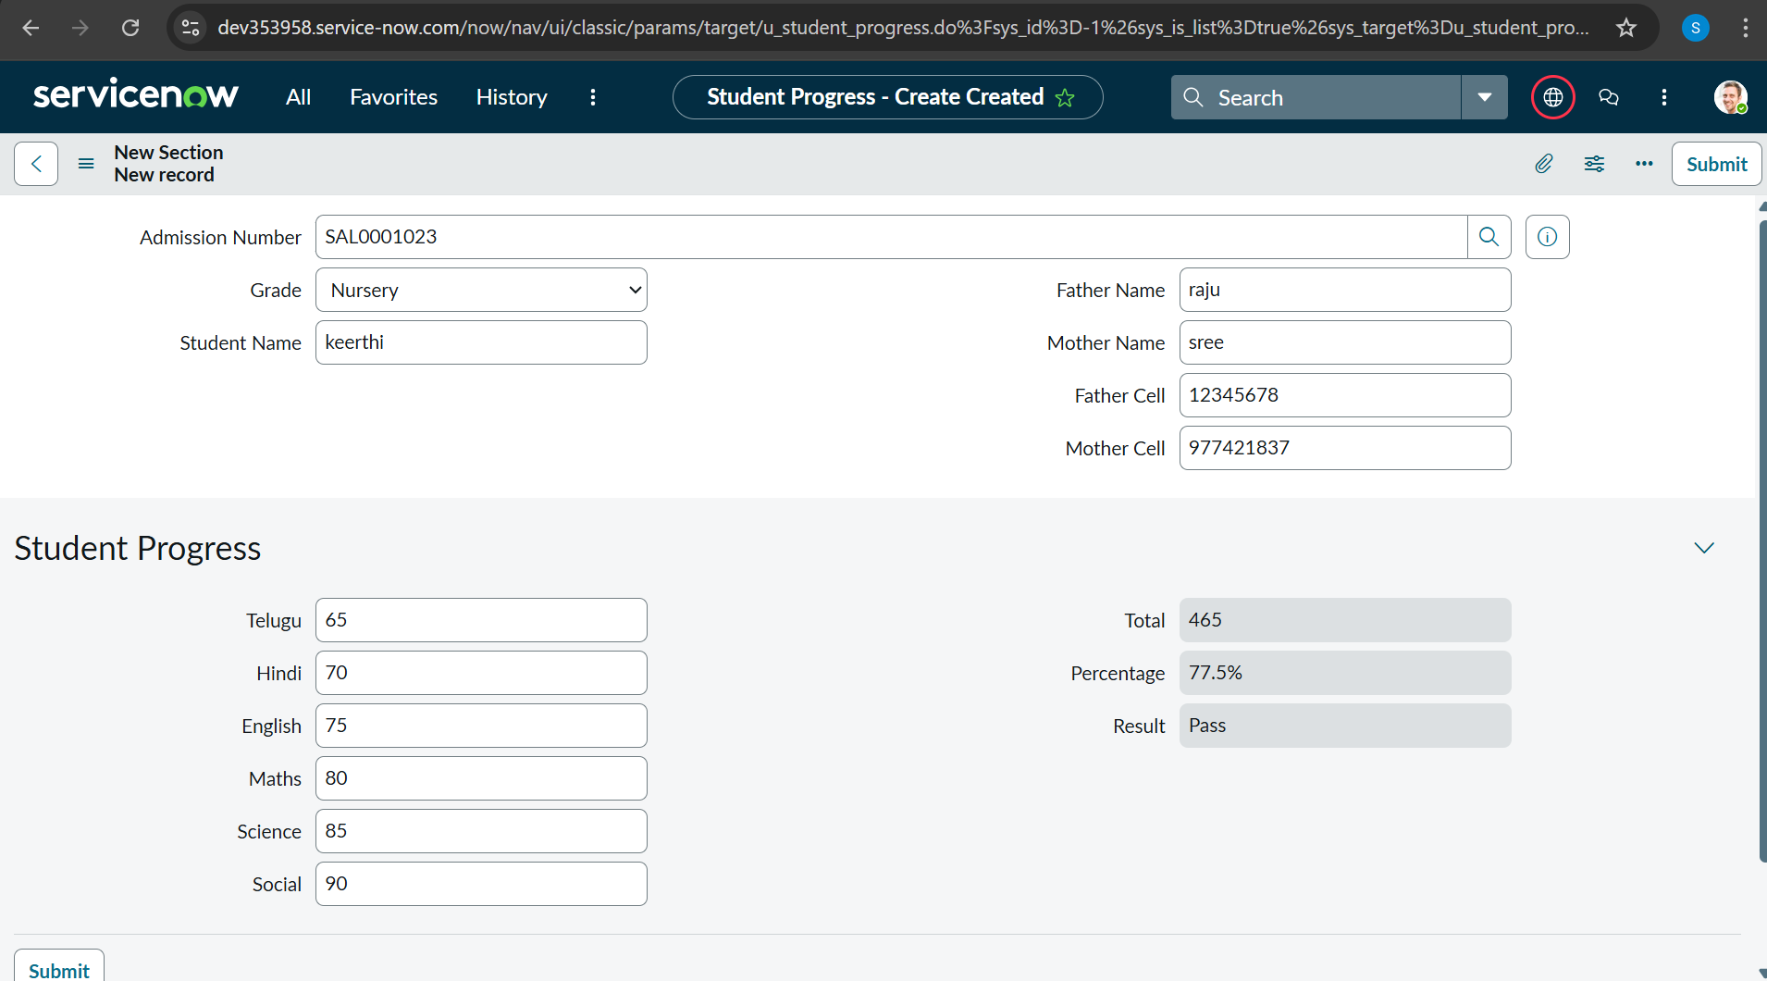
Figure 3: Academic evaluation form with real-time result calculation.

ADVANTAGES & DISADVANTAGES
• Advantages: Cloud-based (no install), fast low-code deployment, and real-time data consistency.
• Disadvantages: Requires internet connectivity and basic ServiceNow UI familiarity.

CONCLUSION
This project demonstrates the effectiveness of the ServiceNow platform in digitizing administrative workflows. By integrating the Salesforce, Admission, and Student Progress tables, we have successfully automated data handling and academic tracking. The implementation of specialized Client Scripts and Process Flows has significantly reduced manual effort while ensuring high data accuracy and real-time visibility into student records.

FUTURE SCOPE
• Analytics: Real-time dashboards for academic performance.
• Notifications: Integrated Email/SMS alerts for status and grades.
• Expansion: Fee and Library management module integration.

APPENDIX
- Source Code
Below are the key Client Scripts used in the application:
- Auto populate Client Scripts for Admission Table :
function onChange(control, oldValue, newValue, isLoading, isTemplate) {
if (isLoading || newValue === '') {
return;
}
var a = g_form.getReference('u_admission_number');
g_form.setValue('u_admin_date',a.u_admin_date);
g_form.setValue('u_grade',a.u_grade);
g_form.setValue('u_student_name',a.u_student_name);
g_form.setValue('u_father_name',a.u_father_name);
g_form.setValue('u_mother_name',a.u_mother_name);
g_form.setValue('u_father_cell',a.u_father_cell);
g_form.setValue('u_mother_cell',a.u_mother_cell);

g_form.setDisabled('u_admin_date',a.u_admin_date);
g_form.setDisabled('u_grade',a.u_grade);
g_form.setDisabled('u_student_name',a.u_student_name);
g_form.setDisabled('u_father_name',a.u_father_name);
g_form.setDisabled('u_mother_name',a.u_mother_name);
g_form.setDisabled('u_father_cell',a.u_father_cell);
g_form.setDisabled('u_mother_cell',a.u_mother_cell);
}
- Pincode Update Client Scripts for Admission Table :
function onChange(control, oldValue, newValue, isLoading, isTemplate) {
if (isLoading || newValue === '') {
return;
}
var a = g_form.getValue('u_pincode');
if(a == '509358')
{
g_form.setValue('u_mandal', 'kadthal');
g_form.setValue('u_city', 'kadthal');
g_form.setValue('u_district', 'RangaReddy');

}
else if(a == '500081')
{
g_form.setValue('u_mandal', 'karmanghat');
g_form.setValue('u_city', 'karmanghat');
g_form.setValue('u_district', 'RangaReddy');

}
else if(a == '500079')
{
g_form.setValue('u_mandal', 'Abids');
g_form.setValue('u_city', 'AsifNagar');
g_form.setValue('u_district', 'Hyderabad');
}
- Disable Fields Client Scripts for Student progress Table :
function onLoad() {
g_form.setDisabled('u_total',true);
g_form.setDisabled('u_percentage',true);
g_form.setDisabled('u_result',true);
}
- Total Update Client Scripts for Student progress Table
function onChange(control, oldValue, newValue, isLoading, isTemplate) {
if (isLoading || newValue === '') {
return;
}

if (newValue){
var a = parseInt(g_form.getValue('u_telugu'));
var b = parseInt(g_form.getValue('u_hindi'));
var c = parseInt(g_form.getValue('u_english'));
var d = parseInt(g_form.getValue('u_maths'));
var e = parseInt(g_form.getValue('u_science'));
var f = parseInt(g_form.getValue('u_social'));
var Total = parseInt(a+b+c+d+e+f);
g_form.setValue('u_total', Total);
}
}
- Result Client Scripts for Student progress Table
function onChange(control, oldValue, newValue, isLoading, isTemplate) {
if (isLoading || newValue === '') {
return;
}

if(newValue) {
var a = parseInt(g_form.getValue('u_percentage')); // Convert the value to an integer for comparison
if(a >= 0 && a <= 59){
g_form.setValue('u_result','Fail');
} else if(a >= 60 && a <= 100) {
g_form.setValue('u_result','Pass');
} else {
// Handle the case if a is out of range (optional)
g_form.addErrorMessage('Percentage should be between 0 and 100.');
g_form.clearValue('u_result');
}
}
}

- Percentage Client Scripts for Student progress Table
function onChange(control, oldValue, newValue, isLoading, isTemplate) {
if (isLoading || newValue === '') {
return;
}
var Total = g_form.getValue('u_total');
var Percentage = (Total/600)*100;
g_form.setValue('u_percentage',Percentage+'%');
}

- GitHub Link
https://github.com/Sheena0205/Educational-Organisation-Using-Servicenow

- Demo Video Link
https://drive.google.com/file/d/1Qem9byDvimuuUPFkOqc5f4jKRNmSExn5/view?usp=sharing

